Agent:

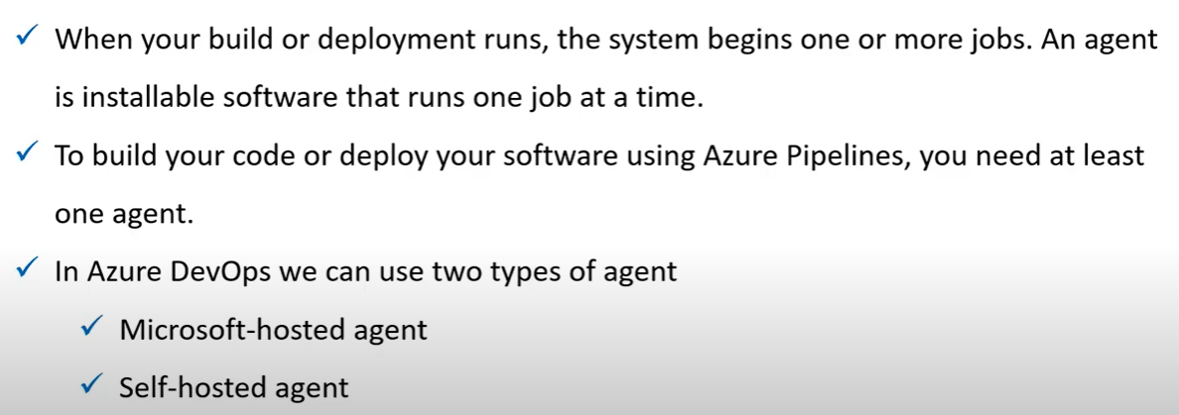

Approvals:

We can also use the approvals in staging.

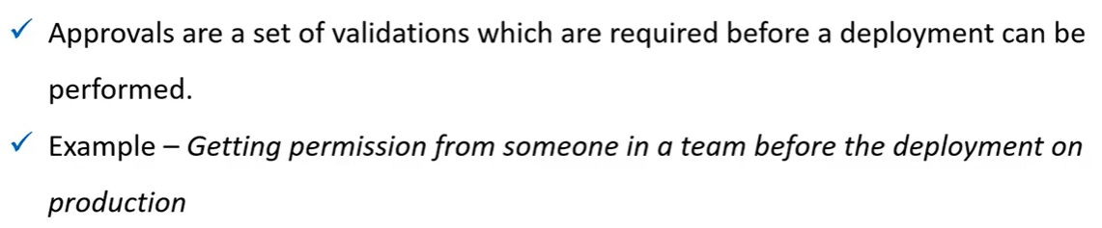

Artifacts:

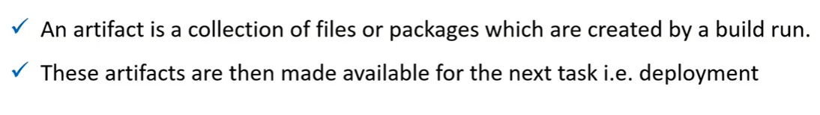

Environment:

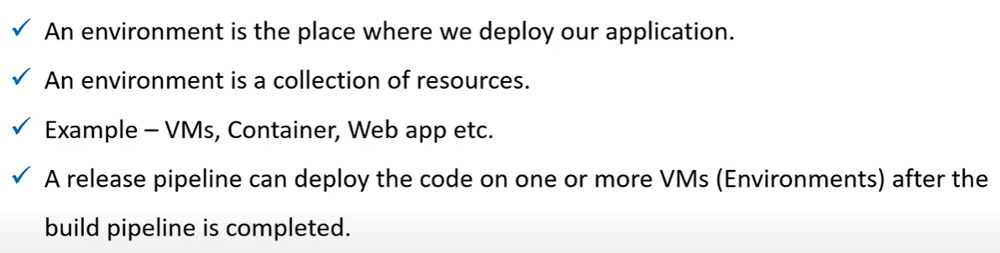

Job:

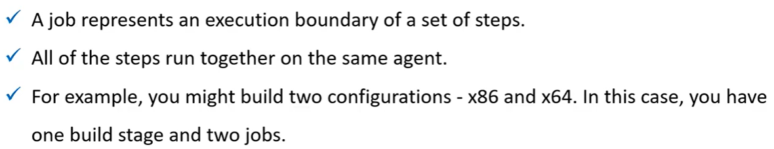

Run:

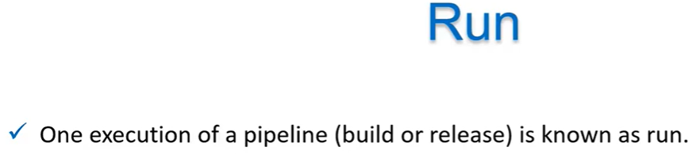

Stage:

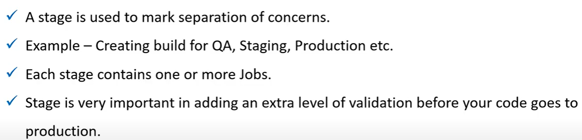

Trigger:

